24SDCS02 / 24SDCS02E / 24SDCS02P / 24SDCS02L – FSAD WORKBOOK
DEPARTMENT OF CSE, CS&IT, AI&DS
COURSE CODE: 24SDCS02 / 24SDCS02E / 24SDCS02P / 24SDCS02L
FULL STACK APPLICATION DEVELOPMENT

Date of the Session: / / Time of The Session: to #SKILL - 1 ⎝ Git Version Control Prerequisites:
• Basic knowledge of Git commands
• Ability to create and edit project files
• Understanding of version control basics
The development team wants to manage their project using Git to maintain a structured and collaborative workflow. In this lab, you will simulate a real-world version control process: creating project files, tracking and committing changes, using GitHub as remote storage, working with multiple branches, and handling merge conflicts. This helps you understand how developers work together efficiently in software projects.

Tasks:
1. Create a new project folder, initialize Git using git init, and configure Git with your username and email.
2. Create two files (example: main.java, notes.txt) with sample content, check the repository status, and add them to staging.
3. Commit the staged files with a meaningful commit message.
4. Create a new repository on GitHub, connect your local repo using the remote URL and push the committed changes.
5. Create the first branch (example: feature-update), make modifications, and add + commit the changes.
6. Create a second branch (example: bug-fix), apply changes, and add + commit them.
7. Switch back to the main branch and merge both branches one after the other.
8. If any merge conflict occurs, resolve it manually, commit the fix, and complete the merge.
Main.java
<<<<<<< HEAD
public class Main {
public static void main(String[] args)
{
System.out.println("Hello Git World!");
}
}
=======
public class Main{
public static void main(String[] args)
{
System.out.println("Hello Git");
}
}
>>>>>>> ba61f104d8705693dc6fe5305eccde6481ff345b
Notes.txt
<<<<<<< HEAD
Local content
=======
GitHub content
>>>>>>> origin/main
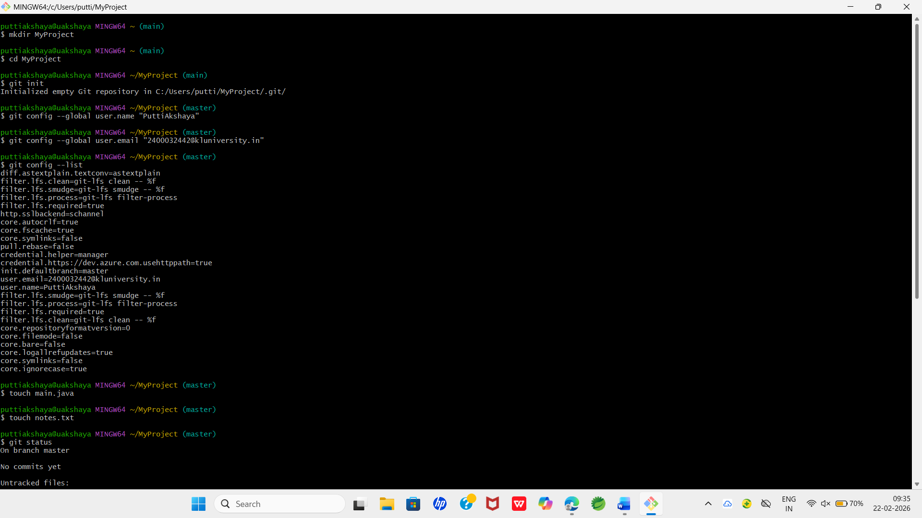
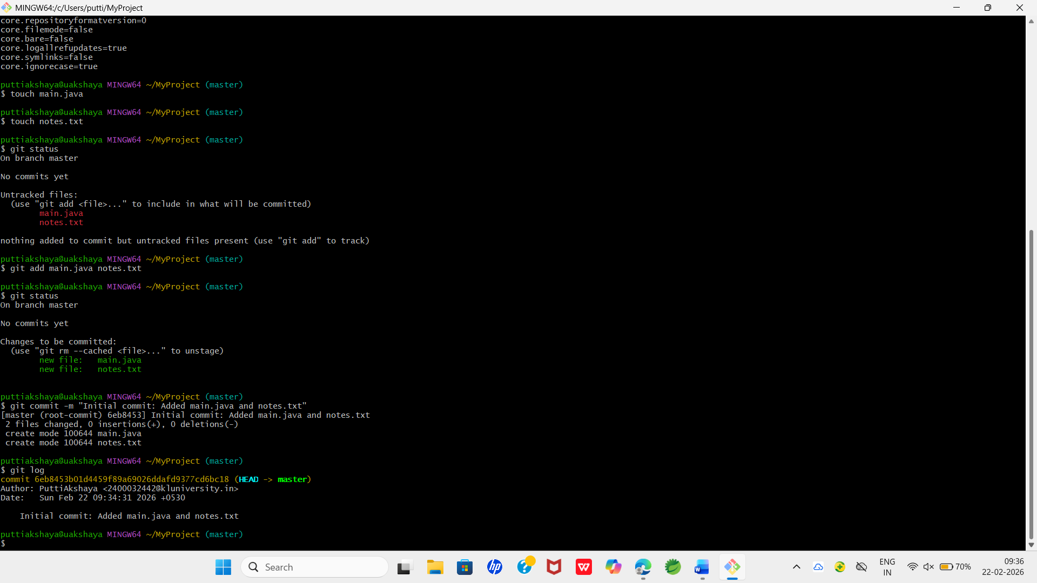
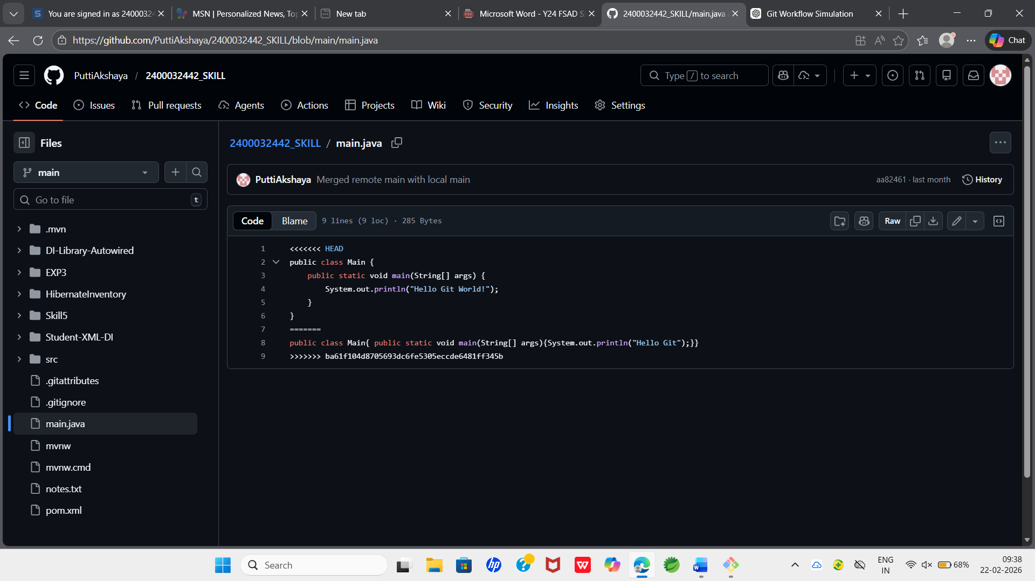

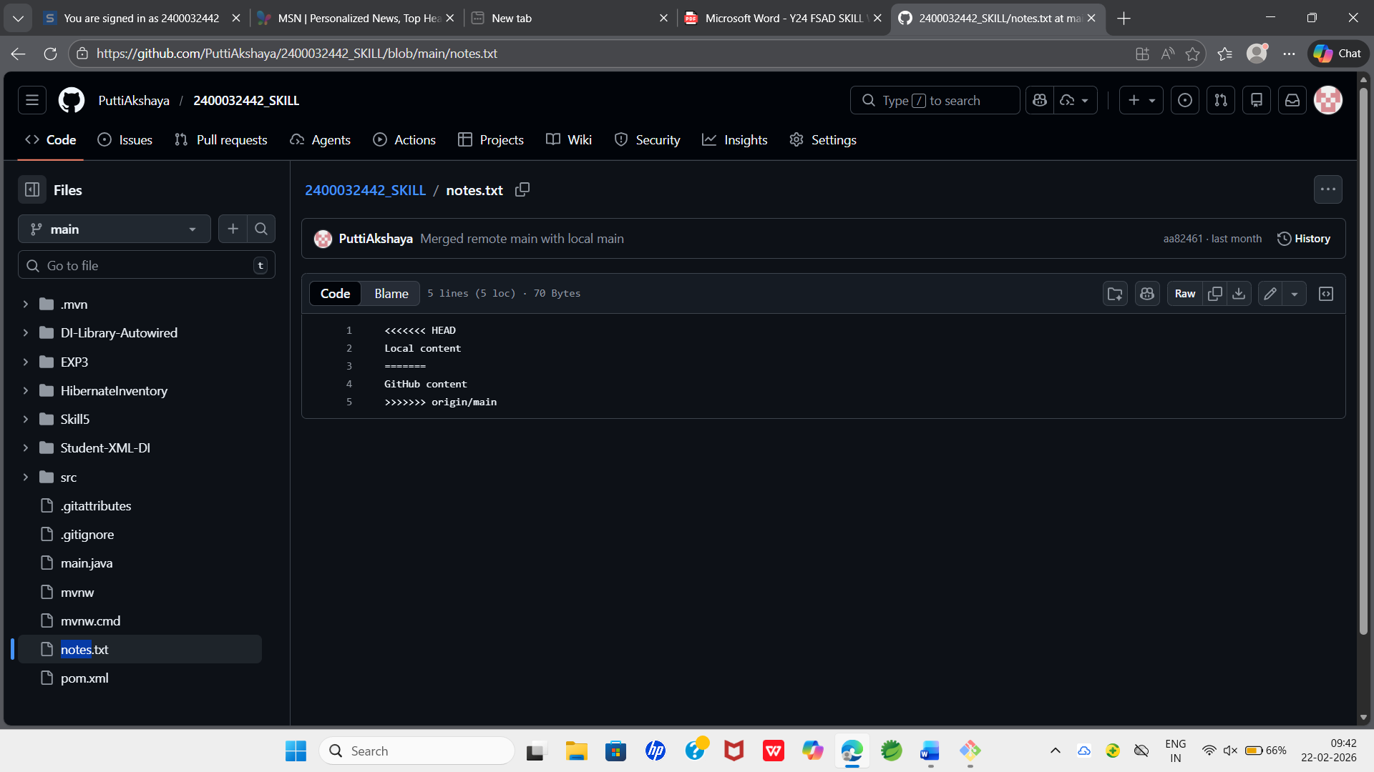

VIVA QUESTIONS:

1️⃣ Why is Git used in development?
Git is used for version control. It tracks code changes, enables collaboration among developers, and allows reverting to previous versions if needed.

2️⃣ What information is stored in Git configuration?
Git configuration stores user details like username and email, default editor settings, and repository-related configurations.

3️⃣ What is Maven and why is it used?
Maven is a build automation and dependency management tool used in Java projects. It manages project dependencies, builds the project, and standardizes the development process.

4️⃣ What is the role of the POM.xml file?
The POM.xml file contains project configuration, dependencies, plugins, build settings, and project metadata in a Maven project.

5️⃣ Explain Maven Build Life Cycle.
Maven Build Life Cycle is a sequence of phases used to build and manage a project. The main lifecycle includes phases like compile, test, package, install, and deploy.

